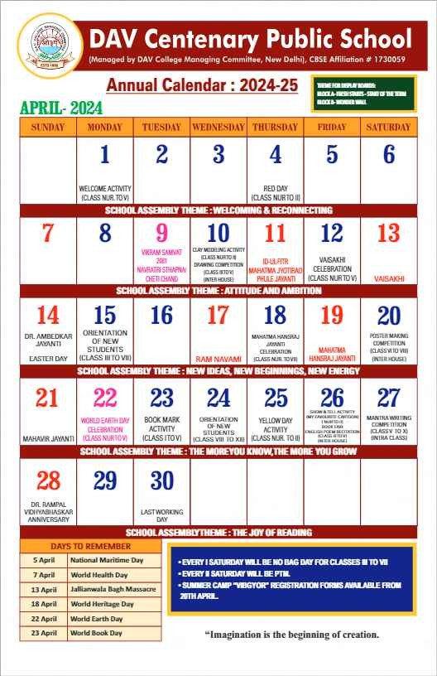

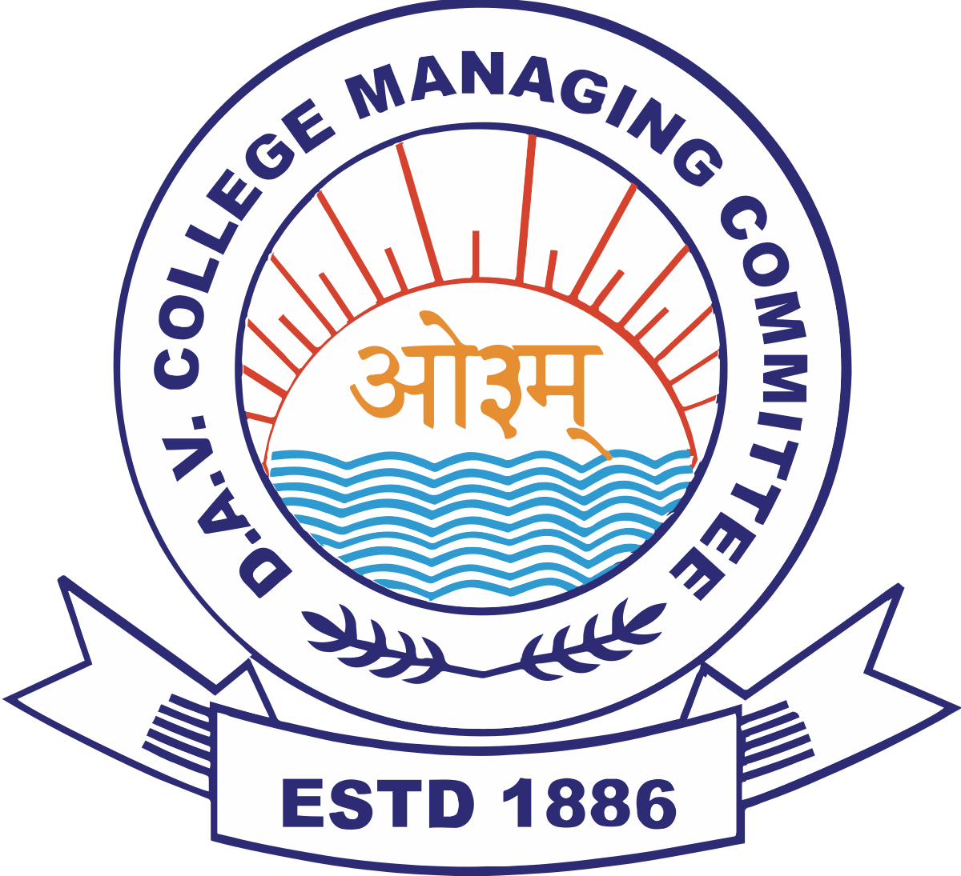

D.A.V. Public School, Behror

(Managed by DAV College Managing Committee, New Delhi), CBSE Affiliation #1730638

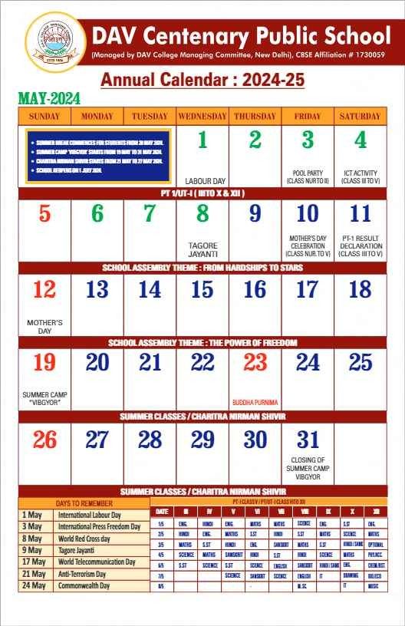



D.A.V. Public School, Behror

(Managed by DAV College Managing Committee, New Delhi), CBSE Affiliation #1730638

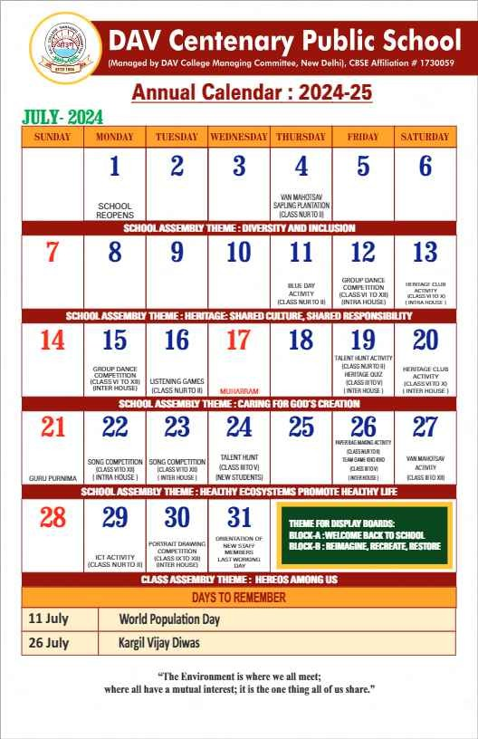

D.A.V. Public School, Behror

(Managed by DAV College Managing Committee, New Delhi), CBSE Affiliation #1730638



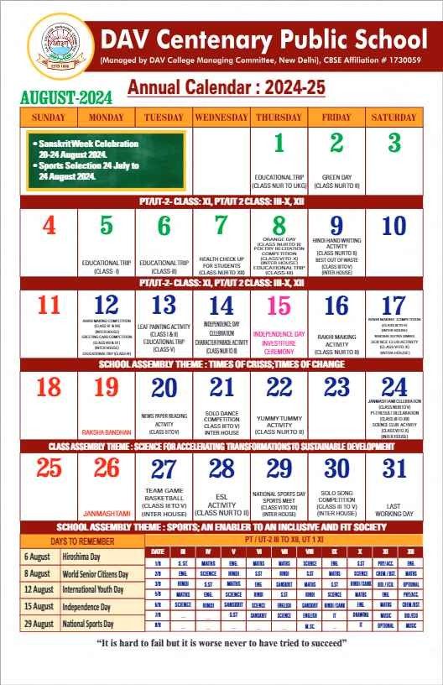



D.A.V. Public School, Behror

(Managed by DAV College Managing Committee, New Delhi), CBSE Affiliation #1730638

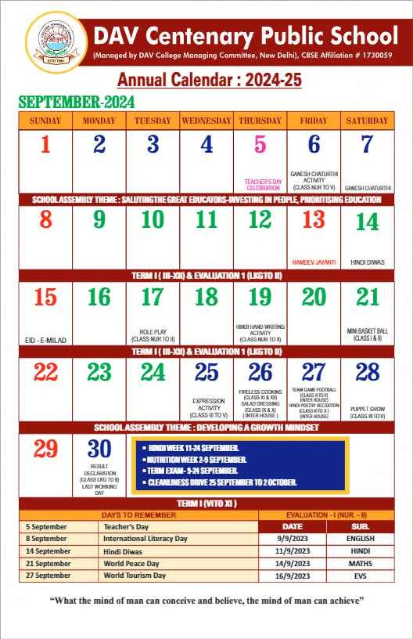



D.A.V. Public School, Behror

(Managed by DAV College Managing Committee, New Delhi), CBSE Affiliation #1730638

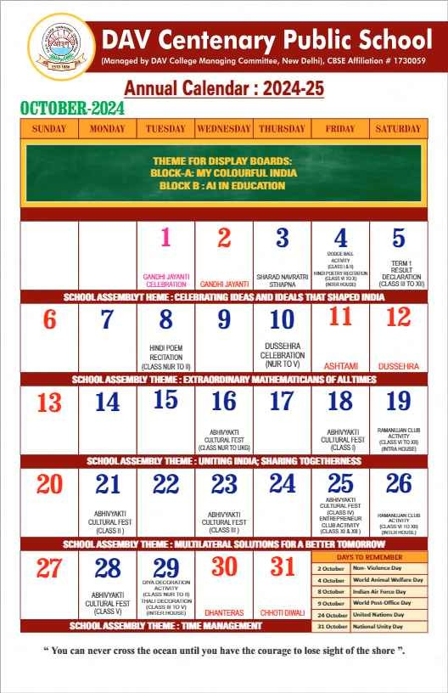



D.A.V. Public School, Behror

(Managed by DAV College Managing Committee, New Delhi), CBSE Affiliation #1730638

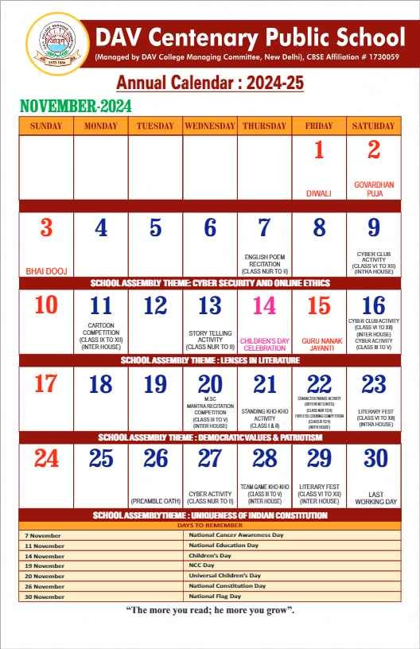

D.A.V. Public School, Behror

(Managed by DAV College Managing Committee, New Delhi), CBSE Affiliation #1730638



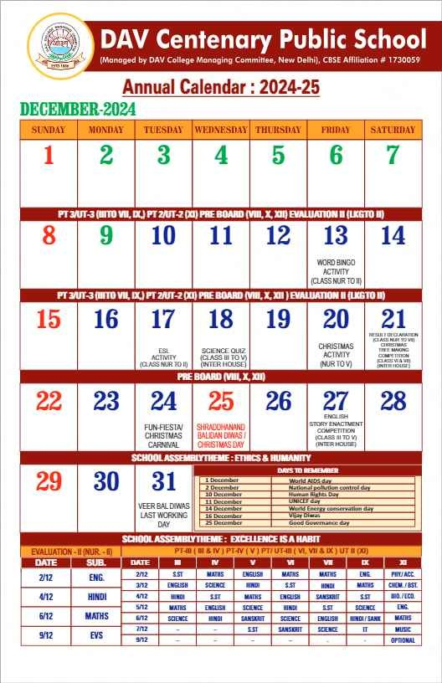

D.A.V. Public School, Behror

(Managed by DAV College Managing Committee, New Delhi), CBSE Affiliation #1730638



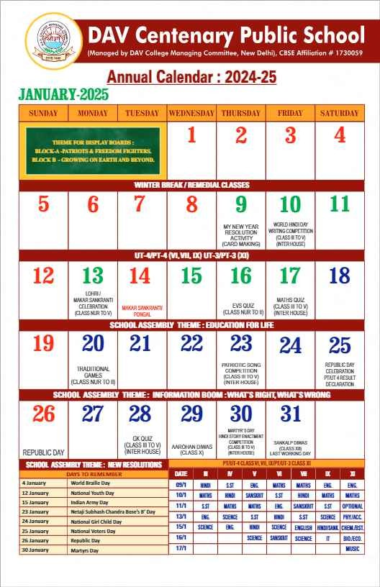



D.A.V. Public School, Behror

(Managed by DAV College Managing Committee, New Delhi), CBSE Affiliation #1730638

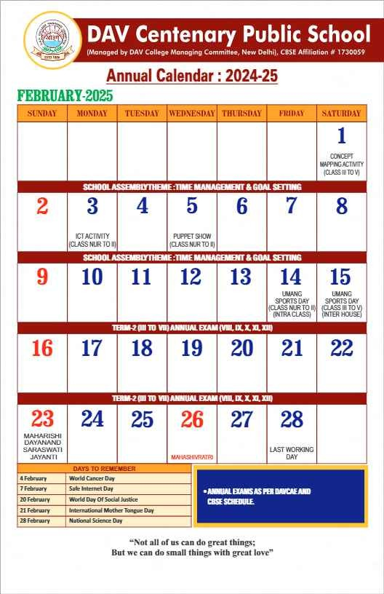

D.A.V. Public School, Behror

(Managed by DAV College Managing Committee, New Delhi), CBSE Affiliation #1730638



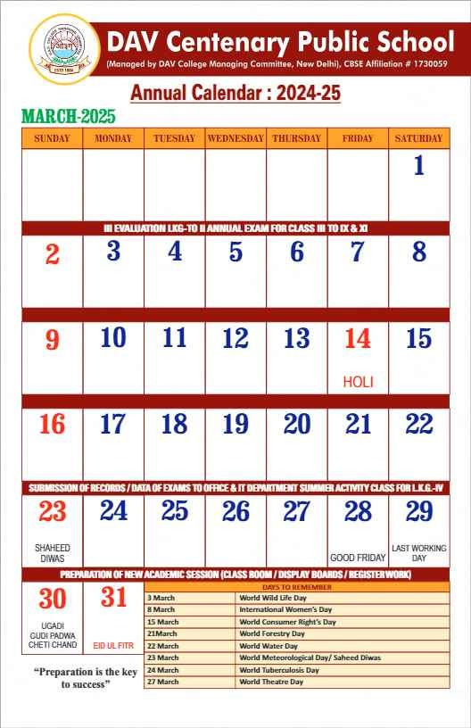



D.A.V. Public School, Behror

(Managed by DAV College Managing Committee, New Delhi), CBSE Affiliation #1730638

